**Chapter 03: System Design Plan**

**3.1 Overview**

This chapter explains the design of our proposed system which has been shown in the block diagrams. The ideas were first established on pen and paper and then rough circuits were drawn. A low-cost, efficient and user friendly microcontroller based Home Automation System has been presented in our design. The system incorporates the use of microcontroller as a control module and uses internet (IoT) for wireless communication between the remote devices and the control module. Our system will allow the users to control and monitor the connected devices inside the home.

**3.2 System Architecture**

Our system has two main modules: the hardware interface module and the software communication module. This section is divided into two sub-sections. First sub-section describes the hardware interface module of the system with a block diagram and the second sub-section explains the software communication module in a block diagram.

**3.2.1 Hardware Architecture**

The Figure 3.2.1 shows a block diagram representation of our proposed system (the hardware section).

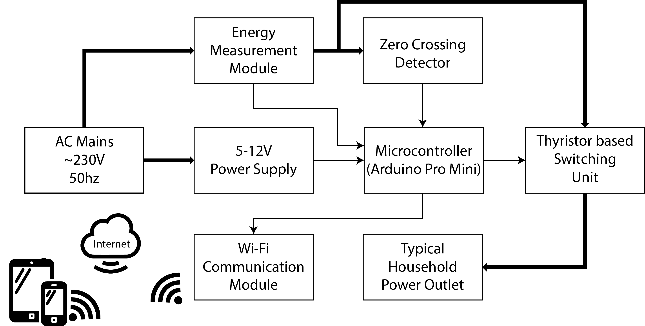

**Figure 3.2.1: The home automation unit block.**

In our system, the device will be controlled through Wi-Fi in an indoor network hub that is connected to the internet. The system will be connected as follows: At the heart of this system, there will be a Microcontroller (Arduino Pro Mini) which can also be capable of functioning as the interface for all the hardware modules. All communication and controls in this system will pass through the microcontroller. The Microcontroller (Arduino Pro Mini) will detect the phase of the AC signal through the Zero Crossing Detector (ZCD) and control the conduction cycle of the AC signal on the output of the Thyristor based switching unit. With the help of a ZCD, users can regulate the amount of power to output to the lights and Fan through the unit, besides having the capability of completely switching them on and off. The user will also know how much power is being consumed by the devices.

The microcontroller will be connected to the user’s home internet connection through Wifi and the controller can communicate with a web browser over the internet. The client request will be sent to the web server using the Django Framework through web browser and then the server will send back the HTTP response to the browser and serve the client’s request which will be displayed on GUI. The device can be controlled from anywhere around the world using any electronic devices that is connected to the internet.

**3.2.2 Software Architecture**

The Figure 3.2.2 shows a block diagram representation of the software section of our proposed system.

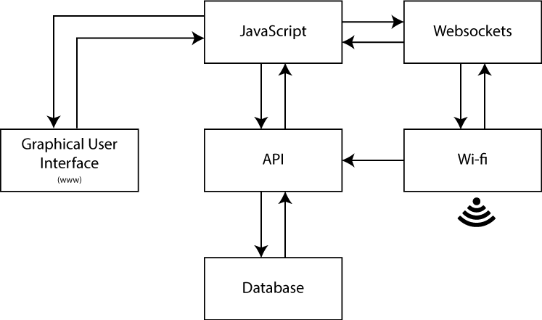

**Figure 3.2.2: The internet block.**

In our project, we will make a Graphical User Interface (GUI) that will act as a server to forward any data to or from the remote device and main control. This web interface will consist of some buttons that will allow users to turn ON/OFF a device and corresponding sliders to control the power output. In this aspect, the API (Application Programming Interface) will work as a service that will take client’s request from the web browser, forward it to the microcontroller and will receive response from there and serve the client’s request simultaneously. The API will also store the data or information regarding the button press on the page (ON/OFF) on a database. With the help of Javascript the user can dynamically press a button ON/OFF or can turn the pin high or low on the webpage.

**3.3 Summary**

Our proposed system will consist of two parts: Hardware and Software. The microcontroller will work as a central hub of the system. The Wi-Fi shield of the system will provide internet connectivity for the embedded micro web server which will allow internet access and will let users to control the devices through a web application. With the help of microcontroller, the users will be able to control devices via a smart device with the use of internet. Our design mainly focuses on controlling the switching of the power outlets that can be used to control various electrical appliances, such as lights and fans or any inductive load that can be voltage regulated. A Zero Crossing Detector and Thyristor based switching circuits will be used for this operation. Our design will propose a low maintenance cost and flexible home control system using smart devices.